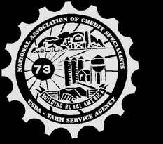
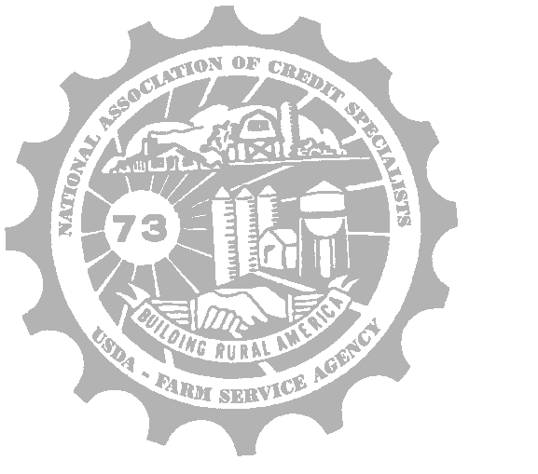
Zone B Newsletter
National Association of Credit Specialists
NACS

Who is Penny?

Recently, the agency created a task force with the intention of increasing efficiencies within the agency and eliminating repetitive work. The task force is led by Dan Gieseke, Farm Loan Chief from Missouri. Dan accepted an invitation to attend Zone B meeting and share with us a little bit about what his task force has been working on. Enter Robotic Process Automation, otherwise known as “bots”.
RPA is software designed to execute computer coded processes automations that mimic human actions for repetitive, rules-based tasks. A process automation is a set of instructions to complete a process or task, and the bot is the application that executes the instructions.
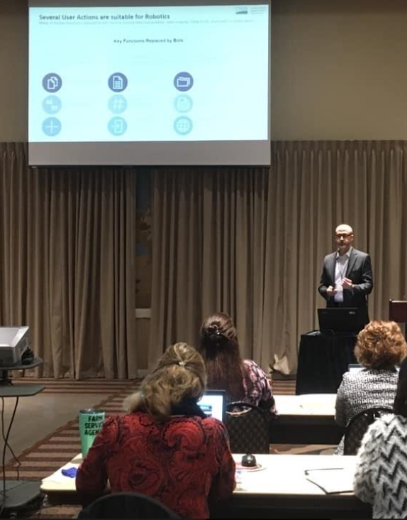
What does that even mean? It means that the bot can automate mundane processes to increase accuracy and allow us (FSA employees) to focus on more complex tasks. The bot can complete the same tasks we are already doing, but faster, and with fewer errors.
The task force has put together a list of about 20 or so repetitive, mundane tasks that they are working to develop a bot that can complete all or most of the task based on information that is already available.
The first bot developed was “Penny.” Penny is the bot that prepares the New Loan Promissory Note. How does Penny work? Through your email! You will send an email to ‘Penny’ at a specific email address, with a specific subject line and information in the body of the email, and she will respond to you via email, with a PDF promissory note with about 75% of the fields pre-filled. She will pull information from other locations, such as DLS, so you will only be required to fill in the remainder of the fields. Penny was planned to go live before the end of March 2020, but due to setbacks associated with COVID-19, this live date has been pushed back again. Penny is currently being tested in a couple of different states.
Some of the other RPAs on the Task Force’s priority list include the 2313, 2307, and 2308 letters, application processing (i.e. accessing different websites and printing those screens), and the streamlining of classifications, YEAs, and graduation reviews.
Even the Undersecretary is excited about RPA, and what it will bring to USDA. He shared an article about ‘Penny’ in the February 7th issue of the FPAC Friday Roundup.

What is coming for FLP?

During the meeting, NACS and NASE members were also able to hear from Steve Peterson, Deputy Administrator for FSA, Bill Cobb Deputy Administrator for Farm Loan Programs, and several staff members from NFAOC.
Due to travel difficulties, Steve Peterson was not able to attend our conference in person, however we were able to improvise with a conference call. Steve shared with our group some information about the farm bill regarding the programs, and that being able to be compensated also means maintaining the cash flow while the economy is down, and that Farm Loa Programs are keeping the producers going during this depressed agricultural economy.
Steve also shared some 2020 budget updates. Total appropriations were 41 billion, with a total discretionary funds of 4.1 billion and 6 million targeted for IT. There is work being done on the staffing model, and that congress is willing to give an additional 35 million toward staffing, after looking at the staffing model.
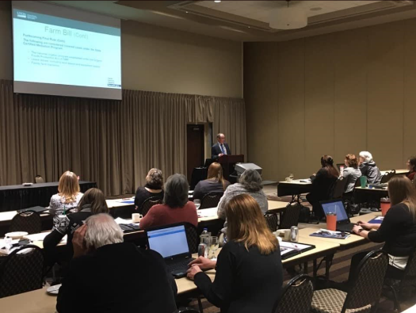
In 2019, there was $8 million designated for FLOT hires that had to be used before the end of fiscal year 2019. This covered about 29 under ceiling FLOTs and about 120 above ceiling FLOTs. Updated Staff ceiling levels should have been set to the SEDs on February 6th.
States were given direct hiring authority for 153 positions including FLOTs. Office of Management Strategy is running a pilot in 10 states to do internal control training. Farm Loan Programs only has 4.5% delinquency, which is the lowest it has been in 30 years. In fiscal year 2019, there was a $328 million increase in loan obligations.
Steve answered questions on the direct hiring process, and the need to re-hire those individuals to get them on the series 11-65 career path, which allows promotion beyond a GS-7.
Bill Cobb shared information about the appropriations bill, and that he hoped the apportionments should be out within a few weeks. Bill also shared that in FY 2018 there was a language change that allowed for unused FLP loan funds to be carried over from one fiscal year to another on loan programs with positive subsidy rates (such as direct OL).
As of January 31st, 2020, the secretary has the ability to increase direct FO allocations by 25% or $468,750,000, which would cover the projected shortfall. PLCE funs have not changed since Fiscal Year 2017, which will likely result in a shortfall for Fiscal Year 2020.
The President’s budget for 2021 is done, and he will soon start working on a budget plan for 2022, Loan obligation are seeing an upward trend in several categories, including Beginning Farmer, SDA, total obligations, and number of obligations. Average obligation for Direct OL loans has increased from $151,000 in 2015 to $194,000 in 2020, as well as an increase in the average size of the direct farm ownership loan from $181,000 to $255,000.
Regulation changes from the Farm Bill are still not published. The National Office staff is working on changes to regulations for the 3 years of management experience eligibility criterion for the direct farm ownership loan. There will also be amendments coming to 4-FLP and 5-FLP including equitable relief provisions, no longer accepting cash payments, and charging a $25 fee for insufficient funds checks.
A teleconference was held with the staff at NFAOC including Sharon Sachs, Ryan Loewe, Amanda Metzger, and Sharon Maull. Each shared some highlights of their program areas, and some common findings.
Overall, NACS and NASE had a very filled and informative joint session with our National Office Speakers, who were able to be candid with their comments, which is always well received and appreciated by our members.

Legislative Committee Updates

We were also able to have a skype video call with Legislative chair Dave Bonnett and Lobbyist Andy Quinn.
Dave shared with the group some of the top priorities for the legislative committee over this fiscal year and going forward. Some of the top priorities include Budget, Staffing Issues, Abolishing Term Limits, Ag Roundtables, and Fundraising.
At the time of the meeting, The President’s 2021 Budget had not been submitted yet. But the committee had plans to be in Washington DC within the next couple of weeks, for a meeting with the appropriations committee. During the meeting, the committee planned to address staffing and the need to staff above and beyond present need in order to maintain staffing levels and to address the training time required.
Andy also stated that there are no Ceiling in statute according to the appropriations committee, they think of staffing in terms of dollars for hiring rather than in the number of people.
Andy also mentions that the White House Environmental Council is discussing that NEPA be removed from guaranteed loans. An update on the fundraising front was also provided, and although it has proved more difficult that initially thought, Andy is continuing to advocate for NACS to other groups on the hill in favor of ‘sponsorships’ from companies such as BASF.

What Can NACS Do For You?
What Can You Do For NACS?

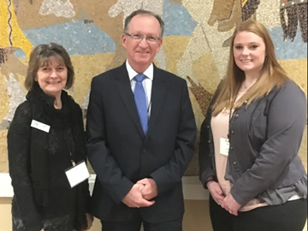
While in Wichita, we were able to hear from the Information Technology, Management/Personnel, Loan Making, and Loan Servicing committees regarding last year’s resolutions and the responses received from National office. There were a wide variety of resolutions for each committee. Our Zone also spent a bit of time discussing the resolutions that had already been submitted for this fiscal year. The resolution process is the basis of how NACS accomplishes goals, and every member is given the opportunity to have their input heard regarding any resolution.
February 25, 2020
If you have strong feelings about something that is going on within FSA, or you think you know a way that we can better serve our customers or make our daily jobs easier. The resolution process is the perfect way to have your thoughts and ideas heard. It has been and continues to be the stance of NACS that when we express a concern, that we also propose a solution to said concern. Through this process NACS has achieved some significant changes to forms, practices, and procedure, to the benefit of our employees as well as our producers.
One of the most recent significant changes that was initiated through the resolution process was the increase of direct loan limits.
In addition, we were also able to hear from the Membership committee. Member retention is always a top priority of this committee. With the significant number of employee retirements, we are seeing, and continue to see, out membership numbers are started to dwindle. These changes to our membership numbers, in turn, have impacts on the budget of the Association.
The committee is focused on letting potential members know the benefits that NACS provides to each of them, and there are so many. NACS has partnerships with companies such as FEDS protection, which members receive a discount for personal liability policies, and Dillard Financial Solutions, who provides retirement and financial planning. NACS also has many professional benefits, such a meeting and building relationships with National Office Staff, serving on task forces, and meeting other individuals from across the nation, who have the same jobs and day to day issues as you.

A Message from your Zone B Representative

This year has been such a whirlwind. We were so fortunate to have all of our Zone Meetings this year before the COVID-19 quarantining began. However, with the risks of travel and gathering in large groups, our National Convention has been postponed. The new dates for convention will be August 30 – September 3, 2020, and convention will still be in Omaha, Nebraska as planned.
In order to make our convention the biggest success it can be, we need your help. This is your friendly reminder to submit resolutions. Over the past several months, with doing more and more tasks electronically and teleworking, there are so many areas where we can dig deep to make beneficial suggestions for changes.
It has been such a pleasure serving as Zone B Representative for the 2019-2020 year. Unfortunately, with growing family commitments for 2021, I will not be stepping down as the Zone B representative. Consider stepping up and getting more involved in the organization. There are plenty of opportunities to serve on task forces, committees, and to run for a board position. Zone B representative is an excellent way to be on the NACS board, and to start meeting and building relationships with National Office Staff, without a significant time commitment.

