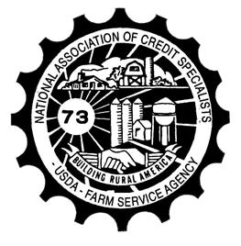

National Association of Credit Specialists

*Building Rural America—Leading the Way*

Revision July 2023

#### Q: What is NACS?

A: The National Association of Credit Specialists is a professional organization of USDA-Farm Service Agency employees working to support rural America. We help bridge the gap between policy makers in Congress and our Agency, with our members providing the ideas and resolutions that help craft improved loan delivery throughout the country. NACS gives you a voice.

#### Q: What is a “Resolution?”

A: The resolution process is the backbone of the Association. It takes *your* concerns and recommendations - or "Resolutions" - and presents them to leadership in the National Office. As members of an organized group, we have greater ability and resources to affect change, and do so by accompanying our concern with a way to improve it. Submit your Resolutions online at any time— every idea will be discussed and reviewed during National Convention by the appropriate Committee and the

delegation. Committees include Loan Making; Loan Servicing; Management/Personnel; Information Technology; and Legislative Issues.

#### Q: What changes has NACS affected?

A: NACS has been responsible for significant changes that have helped provide farmers and ranchers with better access to rural credit. These include:

* Increase in Direct and Guaranteed Loan Limits
* Removal of Guaranteed Loan Term Limits
* Expanding Beginning Farmer eligibility
* Better Streamlined Loan Processing
* Promoting FLOs from GS-9 to GS-11
* Farm Business Plan enhancements
* Contributor to Workload Analytics/Staffing Model

National Office continually calls on the Employee Associations for feedback from the field on systems and programs we work with on a day-to-day basis.

**Q: What do I get out of it?**

A: NACS is a distinguished, professional organization that provides opportunities to its members that are not readily available to others. NACS offers professional development and leadership training. Our members are groomed to be leaders in the field, encouraged to serve on the State or National Board, get involved on a

Committee, submit resolutions for change, and attend Zone Meeting and National Convention. We are respected by policy makers in Washington D.C. and meet with them face-to-face. The networking opportunities are invaluable. Your involvement does more than expand your resume; it adds value to your job and provides vocational training that will serve you throughout your professional career.

*“At the 2022 National Convention, I was able to ask a question to Zach Ducheneaux, FSA Administrator, concerning my borrower. I would not have had this opportunity without NACS” -Amy Larson, MT*

#### Q: What do members of NACS do?

A: *Locally*— State or regional Chapters meet with the SED and other State Office employees to discuss concerns from the field and offer solutions on how to best correct the problems. Members of NACS are often the first to be contacted for state task forces or review groups.

*Nationally*— The National Association meets with the Administrator and National Office staff, providing field office perspective and input on proposed regulation changes.

*On the Hill*—We work with our Legislative Consultant on issues in the Farm Bill to better the delivery of the Farm Loan Programs. NACS members talk directly to Legislators, describing how the agency turns $78.7 million of appropriations into $7.2 billion of capital for farmers and ranchers.

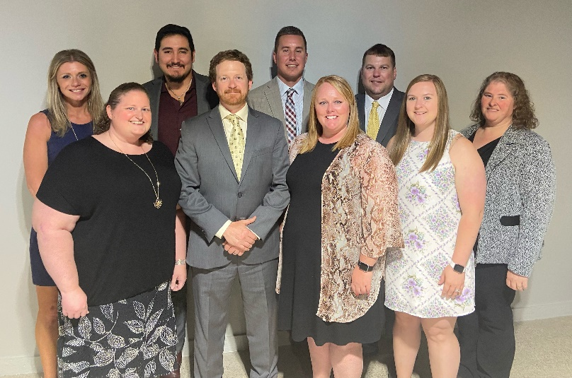

#### Q: When does NACS meet?

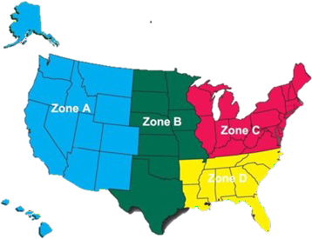

National Association of Credit Specialists

*Building Rural America—Leading the Way*

A: While attendance of any NACS meeting is completely optional, getting to know other FLP employees from around the country is a great benefit to joining the association. Joint Zone Meetings are held in February/March. In June, all Zones join for the National Convention held over the course of

3 days. Locations of

these events change annually and gives you the opportunity to visit many parts of the country.

State or regional Chapters also host meetings, which are organized on a local level.

#### Q: What is the cost?

A: NACS is operated just as a regular business or service club. Dues are collected to support the operations that include:

* Legislative Consultation – supporting Farm Loan Programs in the Farm Bill
* Member reimbursements for Zone Meetings and National Convention
* Board and Legislative travel
* Convention expenses and First Time Attendee reimbursements
* Supplies/business & website expenses

National dues are $6.00 per pay period. Each state or regional Chapter sets their own dues, which may be higher than the national dues. Dues can be automatically withheld from your paycheck by submitting form FSA-444.

2023-2024 NACS Board

**Q: What benefits are available to first-time attendees?**

# A: There is a first-time attendee incentive for members attending National Convention for the first time of up to $200 for travel costs. A drawing is also held at National Convention to win an additional $500 travel reimbursement for one first-time attendee.



National Association of Credit Specialists

*Building Rural America—Leading the Way*

#### Q: What other incentives does NACS provide to members?

A: Reimbursement for travel to National Convention is provided to attending Committee members up to $400 and NACS Board members up to $500. Two days of official time is authorized for each member of the NACS Board and Chapter Delegates to attend National Convention per NACS’s Consultative Agreement with the National Office. Official time to attend National Convention must be approved in advance through the employee’s supervisor or SED.

One day of official time is authorized for one Chapter representative to attend a Zone Meeting for their area per NACS’s Consultative Agreement. Official time to attend a Zone Meeting must be approved in advance through the employee’s supervisor or SED. Typically, the Deputy of Field Operations annually authorizes approximately 4 or 5 hours of administrative leave for all members attending their Zone Meeting per a memo.

*The NACS Consultative Agreement can be found in 3-PM, Exhibit 35.*

**Q: How do I sign up?**

A: You’ve decided to join the majority of your

colleagues and become a member of NACS! Enrollment is easy, just complete the “Yes, I want to Join NACS” form and email to nacs@nacs-fsa.org.

You can also print and submit the forms to

any Board member of your state or regional

Chapter. If you wish to pay dues by check, the

FSA-444 does not need to be completed.

**Q: Where can you find us?**

A: Our website is www.nacs-fsa.org and you can

follow us on Facebook at NACS – FSA.

*“Joining NACS has been one of the best decisions I*

*have made in my career with FSA! I have been able to*

*improve my leadership skills by serving not only as a*

*member and chairperson on our many committees but*

*also as an officer on the Association board, and the*

*networking opportunities that my NACS membership*

*has provided have been invaluable to my*

*career. Being able to meet lots of great people*

*throughout the country and developing life-long*

*friendships has also been an awesome benefit of my*

*NACS membership! I know if I am ever stranded*

*anywhere across this great country of ours, I probably*

*have a fellow NACS member in that state who will*

*come to my rescue if I call!*

*Membership in NACS also gives you a voice and a*

*seat at the table that empowers all of our members to*

*make a positive difference in our loan programs for our*

*borrowers through our resolution process. When you*

*see a resolution recommendation that you made*

*actually become part of our FLP handbooks, it really*

*gives you a sense of pride to know that our leadership*

*recognizes the importance of the ideas that come in*

*from the field office employees! I have never worked*

*for another organization that gives their employees that*

*sort of empowerment!*

*I encourage all FLP employees to consider the*

*benefits that NACS membership can offer. It has*

*certainly given me a lot!”*

*– LeAnn Gibbs, NACS Past President*

***Yes...* I want to join NACS - FSA...**

## The National Association of Credit Specialists of the

**USDA, Farm Service Agency welcomes all FSA employees actively involved in**

**Farm Loan Programs within FSA.**

**We need your support!**

I want to become a member of the Chapter.

(Please forward this information to your state or regional Chapter as well.)

### Zone A: Zone B: Zone C: Zone D:

|  |  |  |  |  |  |
| --- | --- | --- | --- | --- | --- |
| **LAST NAME:** |  | | | | |
| **FIRST NAME:** |  | | | **MI:** |  |
| **JOB TITLE:** |  | | | | |
| **HOME ADDRESS:** |  | | | | |
| **CITY/STATE/ZIP:** |  |  |  | | |
| **HOME PHONE:** |  | **CELL:** |  | | |
| **OFFICE ADDRESS:** |  | | | | |
| **CITY/STATE/ZIP** |  |  |  | | |
| **OFFICE PHONE:** |  | | | | |
| **WORK EMAIL:** |  | | | | |
| **PERSONAL EMAIL:** |  | | | | |
| **COMMENTS:** |  | | | | |

**In effort to provide timely information to members, NACS periodically sends newsletters and messages from the NACS President. By going to the NACS website and clicking on “Sign-up for Email” under Contact Us, you ensure receiving emails.**

**Return this form to nacs@nacs-fsa.org.**

**This form is available electronically.**

|  |  |  |  |  |  |  |
| --- | --- | --- | --- | --- | --- | --- |
| **FSA-444 U.S. DEPARTMENT OF AGRICULTURE**  (06-21-12) Farm Service Agency  **REQUEST FOR OR TERMINATION OF VOLUNTARY ALLOTMENT OF PAY FOR USDA FSA RECOGNIZED ASSOCIATIONS** | | | | | | |
| **NOTE:** *The following statement is made in accordance with the Privacy Act of 1974 (5 USC 552a - as amended). The authority for requesting the information identified on this form is 5 USC § 5525 - Allotment and Assignment of Pay. The information will be used to process an employee request to begin or terminate a voluntary allotment of pay. The information collected on this form may be disclosed to other Federal, State, Local government agencies, Tribal agencies, and nongovernmental entities that have been authorized access to the information by statute or regulation and/or as described in applicable Routine Uses identified in the System of Records Notice for GOVT-1, General Personnel Records, USDA/FSA-6, County Personnel Records, and USDA/FSA-7, Employee Resources Master File. Providing the requested information is voluntary.*  *However, failure to furnish the requested information will result in an inability to process an employee request to begin or terminate a voluntary allotment of pay.*  *The collection of information is completed by current Federal employees and is therefore excluded from the Paperwork Reduction Act Requirement as specified in the 5 CFR 1320.3, and OMB approval is not required for this collection of information.*  *The provisions of appropriate criminal and civil fraud, privacy, and other statutes may be applicable to the information provided.* | | | | | | |
| 1. Name of Employee *(Last, First, Middle)* | | | | | 2. Last 4 Digits of SSN | |
| 3. Home Address of Employee *(Including Zip Code)* | | | | | 4. Name of USDA Agency *(Including Division/Branch)*  Farm Service Agency | |
| 5. State/County of Employment | |
| 6. Association *(Check One)*:  NASCOE | NAFEC | NASE | x NACS | | Other: |  |
| 7. **Type of Allotment** *(Check one)* ***Note:*** *A separate FSA-444* ***must*** *be filled out for each type of allotment*:  x **ASSOCIATION DUES**  I hereby authorize the Farm Service Agency (FSA) all of the following:   * to deduct from my pay on a biweekly basis the amount certified as the regular dues of the Association or state affiliate beginning PP of CY . * to make ***any changes*** in the amount which is certified by the Association or the state affiliate as an uniform change in its dues structure. * to remit the dues withheld to the Association in accordance with its arrangements with FSA.   **SUPPLEMENTAL INSURANCE COVERAGE**  State: Association:    I hereby authorize the Farm Service Agency (FSA) all of the following:   * to deduct from my pay on a biweekly basis the amount certified by me as the premium for insurance elected by me through the NASCOE authorized carrier beginning PP of CY . * premiums withheld will be remitted to the NASCOE carrier in accordance with the agreement between NASCOE and FSA. I understand   that if my pay is insufficient to withhold the premium due, I am responsible for paying such premiums directly to the NASCOE carrier if I want to continue my insurance coverage. | | | | | | |
| *I understand this authorization must be filed with the State FSA Office at least* ***3 days*** *before the end of the pay period in which the first deduction will be made. I further understand this authorization will be terminated at any time I give written notice or in case of my*  *separation for any reason. In either case, such termination will be effective only to prohibit further withholdings.* | | | | | | |
| 8. Signature of Employee Requesting Allotment | | | | | | 9. Date *(MM-DD-YYYY)* |
| 10. **Termination of Allotment** *(Check One)*:  State: Association: I request payroll deduction for the following allotment be terminated on the first day of Pay Period of CY .  NASCOE Dues Supplemental Insurance Coverage NAFEC Dues  NASE Dues NACS Dues Other: | | | | | | |
| 11. Signature of Employee Terminating Allotment | | | | | | 12. Date *(MM-DD-YYYY)* |
| 13. **State Office Action *(Check NFC tables to determine current PP dues, or supplemental amount)*:** | | | | | | |
| A. Date Received *(MM-DD-YYYY)* | | B. Effective Date *(MM-DD-YYYY)* | | | | C. Date Updated *(MM-DD-YYYY)* |
| D. Name of Employee Updating Request | | | | E. Signature of Employee Updating Request | | |

*The U.S. Department of Agriculture (USDA) prohibits discrimination in all of its programs and activities on the basis of race, color, national origin, age, disability, and where applicable, sex, marital status, familial status, parental status, religion, sexual orientation, political beliefs, genetic information, reprisal, or because all or part of an individual’s income is derived from any public assistance program. (Not all prohibited bases apply to all programs.) Persons with disabilities who require alternative means for communication of program information (Braille, large print, audiotape, etc.) should contact USDA’s TARGET Center at (202) 720-2600 (voice and TDD). To file a complaint of discrimination, write to USDA, Assistant Secretary for Civil Rights,*

*Office of the Assistant Secretary for Civil Rights, 1400 Independence Avenue, S.W., Stop 9410, Washington, DC 20250-9410, or call toll-free at (866) 632-9992 (English) or (800) 877-8339 (TDD) or (866) 377-8642 (English Federal-relay) or (800) 845-6136 (Spanish Federal-relay). USDA is an equal opportunity provider and employer.*

#### Save Application

**1 - AGENCY COPY**

#### Submit Application