Building Rural America
National Association of Credit Specialists
of the
USDA – Farm Service Agency
LOAN MAKING COMMITTEE
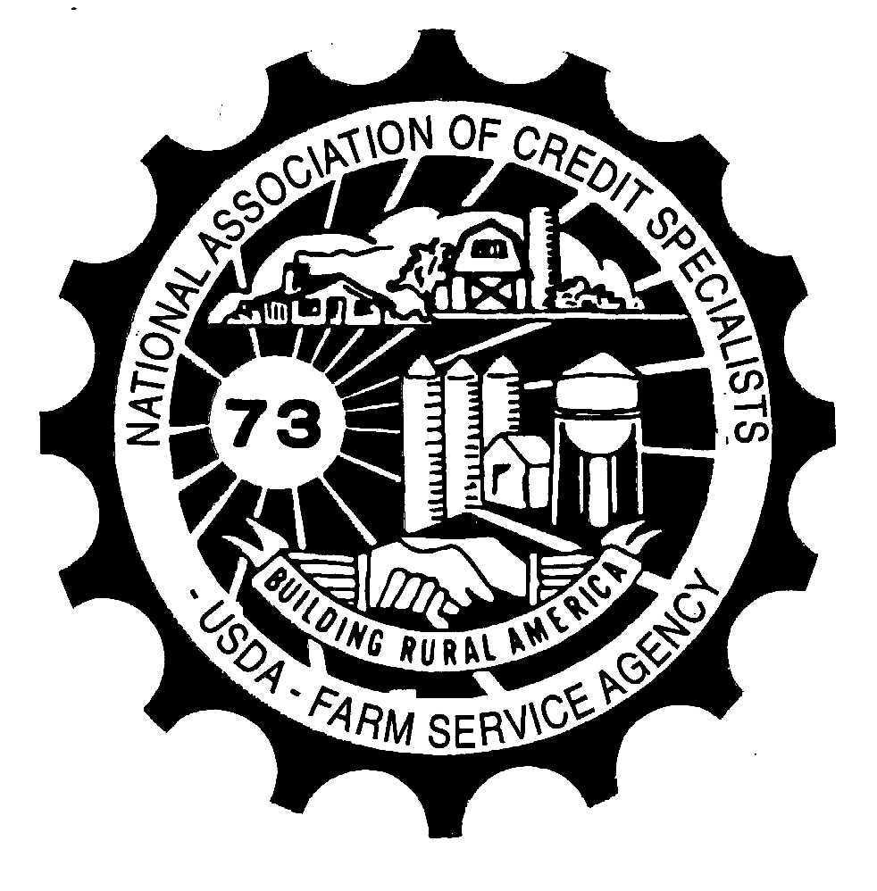

THE LOAN MAKING COMMITTEE MET AT THE HILTON OMAHA IN OMAHA, NE, ON JUNE 26-28, 2023, TO REVIEW RESOLUTIONS SUBMITTED BY THE MEMBERSHIP.

THE FOLLOWING RESOLUTIONS ARE RECOMMENDED FOR ADOPTION:

Resolution 1: Adopt as amended

CONCERN:

7 CFR 764.151(b) and 3-FLP Subparagraph 131 C allow FO funds to be used for the purchase and improvement of farm dwellings. In the language supplementing the CFR, it states the following: FO funds can be used to purchase, improve, or build any type of structure, including a dwelling that either adequately meets family needs and is modest in size, cost, and design, provided the structure is related to the farming enterprise.

There is no guidance for determining if the dwelling or improvement is modest in size, cost, and design. This leads to a great deal of subjectivity that can lead to inconsistency in determinations.

PROPOSED SOLUTION:

Provide clarification for the definition of a “modest” dwelling. A possible solution could be to use Rural Development’s maximum area loan limits per as our limit as well. The Rural Development area loan limits are reviewed at least annually and posted on the Agency website. This limit could also be used in determining if dwelling improvements meet the requirement. If the improvement would result in the Agency estimated or appraised contributory value of the dwelling exceeding the maximum area loan limit, then it would not be considered a modest improvement. Require a State Supplement to provide guidance on a modest sized dwelling for each respective state.

Resolution 2- Adopt

CONCERN:

Most banks generally lend up to 80% of the value. FSA is taking 150% security on direct farm ownership loans. This security requirement restricts the borrower in future financing needs.

PROPOSED SOLUTION:

Require additional security up to 120% instead of 150% security.

Resolution 3-Adopt

CONCERN:

Does the FSA 570 Waiver of Eligibility for Emergency Assistance really serve a purpose for crop insurance?

PROPOSED SOLUTION:

Provide clarification of when the FSA-570 should be completed in FSA loan making.

Resolution 4-adopt as amended

CONCERN:

When a borrower has an outstanding FO loan at $600K and applies for a small annual or term loan, the loan must go to the STO or DD for review and approval. This causes delays in approval with limited staffing or vacancies in these positions. It also causes issues with CQR when these small loans have been approved by the FLC, FLS or DD.

PROPOSED SOLUTION:

Arrange the loan approval chart to address each type of loan and limits for each grade. For example: Grade 11, 12, 13 loan approval loan limitiation to remain at $500,000 for an FO with an additional $50,000 loan authority approval authority for an OL.

Resolution 5- adopt

CONCERN:

On the new FSA 2001, Request for Direct Loan Assistance, for the primary applicant in Part A-Primary Applicant/Farm Operator, it does not have a place to collection information for occupation/employment, like it does in Part D-Other Member Information.

PROPOSED SOLUTION:

Add occupation/employment line for primary applicant.

THE FOLLOWING RESOLUTIONS ARE RECOMMENDED FOR NON-ADOPTION:

Resolution 6 -non-adopt

CONCERN:

In cases of non-applicants pledging security (IE: spouses in marital property states, 3rd party pledges), CCC-10 is required to be signed by the non-applicant authorizing FLP to file a financing statement. This is a redundant action considering the individual would also sign FSA-2028 which already states: "Secured party is authorized to file financing statements describing the collateral, to file amendments to the financing statements, and to file continuation statements." If nothing else the CCC-10 is confusing and generic.

PROPOSED SOLUTION:

Incorporate necessary language, if necessary, into FSA-2028 to cover non applicant's interest in loan collateral.

EXPLANATION FOR NON-ADOPTON BY THE COMMITTEE:

The CCC-10 is required by the non-applicant granting authority to file a financing statement, which can be completed before the signature are obtained the FSA-2028.

Resolution 7 – non adopt

CONCERN:

Having the complete and incomplete letters automated from DLS is great. It saves time by removing the extra steps in creating these letters on our own. However, the bots send the FSA-2307 “Notice of Complete Application” in the form of a Microsoft Word Document.

PROPOSED SOLUTION:

I propose having National Office update the final format to PDF, so we can easily sign by using digital signatures.

EXPLANATION FOR NON-ADOPTON BY THE COMMITTEE:

We feel it is better to leave it as a word document, which is easier to complete in this format rather than in a PDF.

Resolution 8-non-adopt

CONCERN:

Direct loan payments are loaded into NRRS and it takes 3 to 4 days before the producers account shows the correct loan balance. It is a problem when producers come back to apply more money on the direct loans within the 3 to 4 days and DLS/NITC does not show the new balance. -

PROPOSED SOLUTION:

Process direct loan depositing checks more like FSFL and MAL, once the check/money is put in the system the new balance is shown.

EXPLANATION FOR NON-ADOPTON BY THE COMMITTEE:

Until ADPS is updated or obsolete, we realize processing will not be completed in a more timely manner.

Resolution 9- Non-Adopt, move to legislative committee

CONCERN:

1-FSFL Par 60A establishes an FSFL loan limit of $500,000. A borrower may have multiple FSFLs, however each loan cannot exceed $500,000. The arbitrary $500,000 loan limit results in significant additional workload. For example, with large facility improvement projects (i.e. grain bins with legs, conveyers, dryers) and increased cost of materials, labor and construction, many FSFL requests are multi-million dollar projects. Because each FSFL must be for an individual, eligible component, approval officials cannot simply take the eligible costs and divide over multiple loans; the bids for the project must be dissected into separate identifiable project components. The amount of time this consumes to establish loan amounts under the $500,000 maximum, in addition to having to multiple loan numbers, each with its own file, CCC-186, etc, is a burden on staff and borrowers who have to monitor multiple loans.

PROPOSED SOLUTION:

Remove $500,000 FSFL loan limit. There is no limit on the number, or aggregate dollar amounts, of FSFLs a producer can obtain as log as they continue to meet eligibility, so the loan limit is not needed and is costly in terms of work hours.

Respectfully submitted by the 2022-2023 Loan Making Committee:

Rebecca Padilla, NM, Zone A Callie Erickson, IA, Zone B

Vicki Swift, KY, Zone C – Chair Chana Thompson, AR, Zone D

